|  |
| --- |
| Name : Shashank K  Section : CSE 3  ID : SE21UCSE198  DAA-LAB 4 |

**Question**  The objective of this assignment is to implement Strassen's Matrix Multiplication algorithm and analyse its performance compared to the standard matrix multiplication algorithm.

**Libraries Used**

* Numpy for easier matrix applications
* Time for time calculation
* Matplotlib.pyplot for visualization

**Report**

I have implemented straight-forward method (naïve method) and Strassen method in python3 used `time` library to calculate time taken by respective methods on randomly generated matrices.

The plot follows:

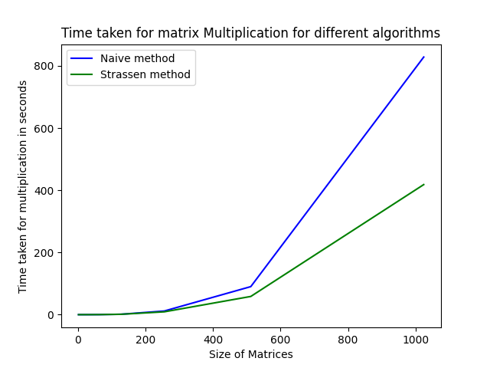

**Naïve method**

|  |  |
| --- | --- |
| Matrix  size | Time Taken (seconds) |
| 2 | 2.4800014216452837e-05 |
| 4 | 4.4599990360438824e-05 |
| 8 | 0.0003384999872650951 |
| 16 | 0.002104800019878894 |
| 32 | 0.01954969999496825 |
| 64 | 0.17290309999953024 |
| 128 | 1.265953800000716 |
| 256 | 11.675154800002929 |
| 512 | 90.14681910001673 |
| 1024 | 828.4701506000129 |

**Strassen Method**

|  |  |
| --- | --- |
| Matrix  size | Time Taken (seconds) |
| 2 | 1.5999976312741637e-05 |
| 4 | 0.00010229999315924942 |
| 8 | 0.00046779998228885233 |
| 16 | 0.0032801000052131712 |
| 32 | 0.024810199975036085 |
| 64 | 0.1606696999806445 |
| 128 | 1.1717945999989752 |
| 256 | 9.067763700004434 |
| 512 | 58.52060299998266 |
| 1024 | 418.2964409000124 |

**Conclusion**

* From the results and the results we can see that for small sized matrices naïve method is better compared to Strassen method
* For small sized matrices the excessive recursions become and hindrance but as size of matrix grows the efficiency of Strassen method shows resulting in blazing fast results.

Complexity of Naïve method : O(n^3)

Complexity of Strassen Method: O(n^2.81)